New Dissertation Cut/Slant
1/10/98

This dissertation is concerned with the development of a practical hardware architecture that represents a new computing methodology. The goal is to develop a machine capable of analyzing and solving arbitrary complex problems very quickly.

The hardware architecture proposed must be equally comfortable and effective solving toy puzzles, playing checkers, analyzing speech, or figuring out the best way to get across a stream by stepping on the dry rocks one can see.

In order for a machine to be general purpose, it must not require carefully-crafted “heuristics” or “knowledge-bases” to solve a new problem. The system must be capable of synthesizing solutions from only a knowledge of what the problem is, what the allowable actions are in solving it, and what the desired outcome is. We will call these Situation, Rules, and Goal, and any problem, puzzle, or game, synthetic or real-world, may be described in these terms.

The most obvious way to construct such a general purpose machine that did not require special “programming” to solve a new problem would be to build an exhaustive search machine. Exhaustive search involves simulating every possible outcome based on every possible sequence of actions. Exhaustive search, or “brute-force” computing, has typically only been effective for the simplest of problems.

Several factors suggest that a re-examination of exhaustive-search-based computing is timely. First, the continued explosion of digital computing power means that many problems unsolvable with brute-force techniques just a few years ago may now be directly solved through the application of more computing horsepower.

A second, more compelling reason to reinvestigate exhaustive search, is the continued revelation of architectural details in animal brain. Most animals, especially humans, are capable of solving a variety of problems that digital computers still have a very difficult time with. Further, the learning capability of animal brains is entirely unduplicated in digital computer architecture, since digital computer require such explicit programming on a per-problem basis that learning seems a daunting task.

The most interesting development in our understanding of brain architecture is that a large number of relatively small and very similar processing circuits seem to be responsible for problem solving in all areas, including logic, reasoning, speech recognition, speech synthesis, vision, and motion control. In humans, for example, a network of about 10⁶ cyclindrical processors, each made up of 2000 neurons or so, comprise the outer covering of the brain, known to be responsible for most of the sophisticated processing upon which we humans pride ourselves so much.

The fastest and most sophisticated computer in the world has useless output unless it has meaningful input. Input comes from sensory data, but must also come from stored knowledge. It seems that in general, the more stored knowledge and sensory input system has, the more likely it is to be able to solve problems presented to it. The ability of current computer systems to receive sensory input and manage databases of information dwarfs those of the human mind. So the key element of brain power must lie in the processing technology used to analyze the data.

intro the probe

show it solving 8 puzzles
note we’re grossly outhinking human capacity here, since we have digital memory and humans don’t

Note no guarantee of “optimal” solutions
We often get sidetracked by the search for the “optimal” solution. The problem with optimality is that, for real-world problems, the definition of optimality is so subjective that the ultimate, “optimal” solution may be ambiguous.

Instead, we suggest the term “acceptable solution.” An acceptable solution is any solution that satisfies at least one of the following criteria:
- A solution which optimizes a specific criteria (the classical definition)
- A solution which almost optimizes a specific criteria
- A solution which does not satisfy any given definition of unacceptability

It is assumed that any solution satisfying number 1 will also satisfy 2 and 3, and that any solution satisfying 2 will satisfy 3. Thus, a complete definition of acceptable solution is

Acceptable Solution: A solution which does not satisfy any given definition of unacceptability

There may be many acceptable solutions, and there may be some acceptable solutions that are more acceptable than others. For this reason, we will always try to find the most acceptable solution, or MAS.

show it choke on 15 puzzles, which we know humans can do

intro stepped goals, but problem is how to pick steps?
Humans instinctively pick a “few-at-a-time” approach bounding?

Coverage Analysis
This section examines the question of how many probes are required to generate an acceptable solution to a problem. Alternatively, this can be though of as a way to determine what size goal steps are safe for a particular proble, given the number of probes available.

It is necessary that we develop the ability to determine the quality of the solutions generated by random probing. The purpose of this exploration is twofold:
- Determine whether particular solutions are likely to be acceptable
- Determine what number of probe cycles would be required to successfully attack particular problems
- Determine whether particular choices of stepped goals make solution feasible given hardware constraints

We start by defining some basic problem variables. Let:

d = probe depth (number of forward simulations)
b = average branching factor in problem
n = number of probe cycles run to depth d
s_{i} = a particular probe outcome, characterized by its series of picks {p₁, p₂, … ,p_{d}}
S = the set of all probe outcomes after a run {s₁, s₂, …, s_{n}}

Recall that in probe processing, the hope is that the optimal solution is a member of S, since the best member of S will be delivered as our proposed solution.

Noting that the number of possible probe outcomes is determined by the complexity and depth of the problem, we let k be the number of possible probe outcomes:

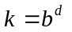

We know n probes explore n probe sequences to generate n probe outcomes. Since each probe discovers one of k final situations, there are k^{n} possible outcomes for S.

Each duplicated final probe situation in S is wasted effort; since investigating the same action sequence more than once tells us nothing new. Further, the order of the probe outcomes in S is unimportant, since we do not care which probe generates the acceptable solution.

We introduce the use of the term “coverage” to describe what fraction of the possible probe outcomes is actually found in S. Ideally, we would like the coverage to be 1, since this represents complete exhaustive search and guarantees discovery of MAS.

Let:
c(n) coverage fraction after n cycles
f(n,i) number of possible ways to generate exactly i distinct members of S after
n cycles

Properties of c(n):
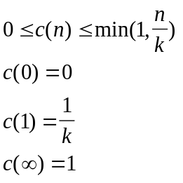

We know experimentally that:
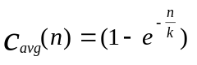

We can develop an average coverage expression using probabilities. Since:

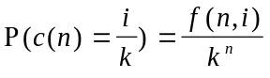

Then:
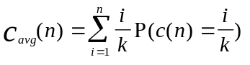

We have derived that:

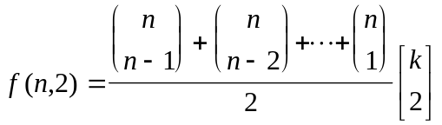

It is experimentally noted that this exresion is equivalent to: f(n,2) = 2 ^ (n-1) -1

Further, it is apparent that:

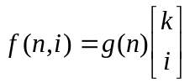

where g(n) has no dependency on k.

